***IoT Based Flood Prediction System***

**VIVEKANAND EDUCATION SOCIETY INSTITUTE OF TECHNOLOGY**

**Name: TANMAY JITENDRA SHINDE**

**DIV: D6A**

1. **Problem statement Understanding:**

Flood disasters affect millions of people across the world by causing severe loss of life and colossal damage to property. Internet of things (IoT) has been applied in areas such as flood prediction, flood monitoring, flood detection, etc .Floods are the most common type of natural disaster they occur when overflow of water submerges the land that is usually dry. Floods are commonly caused by heavy rainfall. Due to climate change the frequency of floods have increased in the last 10 years. The Flood Magnitude Value is a measure of how severe the flood is but rainfall can increase any time and due to it the water level in the sea’s and river rises to such a level which causes floods. There are different technologies that are used such as surveillance technology which uses unmanned drones, satellite technology etc. But all of these techniques are not very accurate. For example: if we take 26th July 2005 incident that occurred in Mumbai a total of 1094 people lost their lives because the flood prediction was not accurate. If we create a system which can alert the citizens beforehand then we can save lives as well as we can prevent destruction of property.

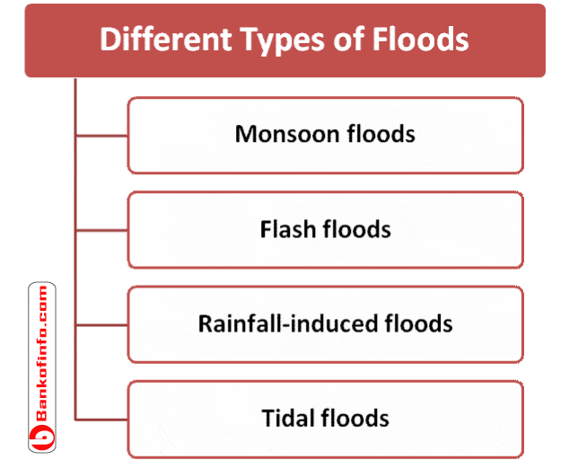

1. **Software and Hardware Requirements**:

**HARDWARE**

1. Wifi Module
2. Arduino UNO
3. Breadboard
4. LED’s
5. Buzzer
6. Temperature Sensor (LM35) range: -55C to 155C
7. Ultrasonic Sensor(HC SR04) range: 2cm to 4m
8. Male/Female Jumper Wires
9. 9V Battery
10. LCD display

**SOFTWARE**

1. Arduino IDE
2. C programming software
3. A Messaging API
4. Proteus
5. **Objective**: The objective of thesis is to design and implement a system for real-time short-term flood prediction that uses data from IoT sensors and makes a forecast of a flooding event using a low power edge device. The study focuses on two major aspects. One is application of various sensors for ahead of time flood prediction implemented on a low power edge device. The second aspect is designing the flood prediction system to operate on low power through the utilisation of ultra low power IoT wireless communication technology.
6. **Addition & Updates**: We are adding a messaging API which will send message to all the citizen in the city. The first aspect is on the possibility of observing more futures for predictions, in addition to water level and rainfall values, to improve the performance of the model when predicting floods further in time, for short-term (e.g. 10 to 15 hours ahead). Environmental conditions that affect rainfall such as humidity, air pressure, temperature, etc., could be observed by sensors to improve the performance of the model when forecasting. Various Additions can also be done to improve the conditions of dams which may overflow so that we can give the warning ahead of time.
7. I) **Application**: It can be used for prediction and detection of floods.

II**) Advantages**: i) We could know the rise or fall in temperature using lm135.

ii) We could know the water level in dam’s, sea or rivers.

iii) Due to this countless number of human lives, cattle can be saved.

iv)Destruction of property can be prevented.

III) **Challenges**: i) We will not be testing this system in a real life flood but just under flood conditions.

ii) In the situation of Covid it is difficult to buy the hardware.

1. **Conclusion**: Nowadays the Internet Of things (IoT) is broadly used in worldwide, this system will display the data of the water level measured on lcd display. This project can be very helpful to the Meteorological Department to continuously monitor the dams and river beds water level. With this project it can save many people lives by giving alerts when the water level crosses beyond the limit. This project is very cost-effective, flexible and productive in areas where flood conditions happens everytime.
2. **References**: i) Pengel, BE, Krzhizhanovskaya, VV, Melnikova, NB, Shirshov, GS, Koelewijn, AR, Pyayt, AL, Mokhov, II, et al. “Flood early warning system: sensors and internet”. In: IAHS Red Book 357 (2013)

ii) Satria, Dedi, Yana, Syaifuddin, Munadi, Rizal, and Syahreza, Saumi. “Design of Information Monitoring System Flood Based Internet of Things (IoT)’”. In: Proceedings of MICoMS (2017)

iii) <https://en.wikipedia.org/wiki/Floods_in_India>

iv) Eric Samikwa “Flood Prediction System Using IoT and Artificial Neural Networks with Edge Computing” Master Thesis (2020)